Penn State Version of the Newhall Simulation Model (psuNSM)

Functional Requirements

Revision 4.0

16 April 2010

Org.\Dept. | Signature | Date
NRCS
CEI

Revision History

Revision | Date | Originator | Description
1.0 | 11/11/2009 | J. Sloan | Original version
2.0 | 2/9/2010 | J. Sloan | Second version
3.0 | 3/18/2010 | J. Sloan | Third version
4.0 | 4/16/2010 | J. Sloan | Fourth version

Table of Contents

Purpose 4
Overview 4
Description: Code conversion, Code enhancements 5
Use Case 5
Requirements 5
Needs 7
Bibliography and Suggested Reading 8
Appendix A: Contents of input data file 10

Purpose
The USDA-NRCS National Geospatial Development Center, under cooperative agreement with the Penn State Center for Environmental Informatics (CEI), seeks to improve access and usability of the Newhall Simulation Model (NSM) (Van Wambeke et al., 1992) to understand soil climate—in particular soil moisture and temperature regimes determined from long-term climate records. This project will deliver an easy-to-use application compatible with the current USDA-NRCS information technology operating environment. The application will be known as the Penn State version of the Newhall Simulation Model (psuNSM). Additionally, we will provide a strategic road map for future development and implementation of psuNSM and related capability.
The objective of this project is to enable a user to submit climate input datasets to the psuNSM for execution and receive summary information products of the results.

Overview
- Newhall Simulation Model code will be (1) converted to a new language, and (2) made to run in the NRCS computing environment.
- For the code to be converted the NRCS has selected and accepted the code content of the version referred to as Van Wambeke 1.0. (Van Wambeke et al., 1992; Van Wambeke, 2000)
- The user will provide a serially-complete dataset of climate data for the desired period of record, and specify the unit system used.
- Input parameters for root zone available water capacity and soil/air temperature relationship will be specified by the user.
- Output will include metadata; model output: values and graphs of rainfall, air temperature and evapotranspiration; temperature and moisture calendars; and various threshold values pertaining to the moisture control section of the model output; a table of model outputs.
- The proposed project is single-phased.

Description: Code conversion, Code enhancements

Use Case

To:
Run the Penn State version of the Newhall Simulation Model (psuNSM) in either an interactive mode or a batch mode, supplying appropriate input data and parameters, and creating desired output.

The interactive mode will allow the user to specify one set of station parameters and one data-input file.

The batch mode will allow the user to specify 1-n self-contained input files and then run model sequentially for each input file. (By self-contained input file we mean a file that contains all required station parameters and data.)

Scenario:
- The user creates a file or files (.csv) containing climate data properly formatted according to the psuNSM input file standards.
- The tool is started:
- Interactive mode is chosen. Station-specific input parameters are set, and the input data file is designated.
OR
- Batch mode is chosen. A set of 1-n input files are designated.
- The Newhall Simulation Model (psuNSM) is run.
- Output data and a report are generated.

Specifics regarding input parameters and input data file formats for NCSS field soil scientists and for regional/national soil scientists will be elaborated upon in the system design specification document.

Requirements

The Penn State version of the Newhall Simulation Model code
- The Van Wambeke 1.0 version of the model will be converted from BASIC code to JAVA code, in order for it to be easily executed on NRCS computers. The converted code will be referred to as the Penn State version of the Newhall Simulation Model code (psuNSM).
- The conversion will NOT involve any modification of the Soil Moisture Regime or the Soil Temperature Regime components as they can be directly related to current soil taxonomy.
- The converted model code will be tested and validated by a peer group selected by the NRCS.

Model Input
- Climate Data
  - The user will be able to select an input dataset(s) that they have prepared according to the defined psuNSM format. The input climate data for each model run will be one or more serially-complete datasets comprised of monthly averaged temperature and precipitation data collected at a site or weather station.
- Input Parameters
- The user will specify whether the longitude-latitude location of the station is in (1) Degrees and Decimal Minutes (DDD MM.M) or (2) Degrees Minutes Seconds (DDD MM SS.S).
- The user will specify whether the unit system of the input data is SI or English.
- The user will supply the time period range of the input data, including the start year and end year.
- The user will be able to specify input parameter values for certain local conditions specific to the site or station:
  - root zone available water holding capacity (RZAWHC), and
  - soil/air temperature (Mean Annual Soil Temperature = Mean Annual Air Temperature + 1.0, or + 1.8, or + 2.5).
- The user will designate the earthly hemisphere
- The user will designate the elevation of the station/site
- Station/Site Metadata
- Optionally the user may specify metadata: Station Name, StationID, State, Country, Contact info, Notes, MLRA, etc.

(Appendix A summarizes the above data categories in list form.)

Model Output
An output report will be created that includes:
- A metadata cover page. (Includes site/station attributes plus date of psuNSM model run and any URL referenced).
- Model Results Summary (See Appendix B, page 1)
  - Monthly values of precipitation, air temperature, evapotranspiration, and soil temperature in user-specified units.
  - Temperature Calendar indicating soil temperature (<5°C, between 5°C and 8°C, >8°C) by calendar day.
  - Moisture Calendar indicating predicted average soil conditions (Dry, Moist/Dry and Moist) by calendar day.
  - Number of cumulative days that the moisture control section is:
    - Dry, Moist/Dry, Moist in one year
    - Dry, Moist/Dry, Moist in one year when soil temperature is >5°C
  - Highest number of consecutive days that the moisture control center is:
    - Moist in some part of the year (T>8°C)
    - Dry after summer solstice
    - Moist after winter solstice
  - Tentative soil climate regime classification
  - Water balance: Mean Annual Water Balance and Summer Water Balance values
- Table of input climate data
- Table of model outputs (see Appendix B, page 2)
- Graphs of the climate data, in user-specified units (see Appendix B, page 3)

In addition all of the above information will be output in a .csv file.

Needs

The original source code of the Van Wambeke 1.0 version of the Newhall Simulation Model. (VanWambeke et al., 1992; VanWambeke, 2000).

Bibliography and Suggested Reading

Bragulat, E.J. 1989. Modelos Matematicos del Regimen de Humedad de los Suelos. Aplicacion a la Determinacion del Regimen de Humedad de los Suelos del Area Meridional de Lleida. Ph.D. diss. Universidad Politecnica de Catalunya.

Costantini, E. A. C., F. Castelli, S. Raimondi, and P. Lorenzoni. 2002. Assessing Soil Moisture Regimes with Traditional and New Methods. Soil Sci. Soc. Am. J. 66:1889–1896.

Goddard, S., S. K. Harms, S. E. Reichenbach, T. Tadesse and W. J. Waltman. 2005. Geospatial Decision Support for Drought Risk Management. Communications of the ACM January 2003, 46.

Jeutong, F., K. M. Eskridge, W. J. Waltman, and O. S. Smith. 2000. Comparison of Bioclimatic Indices for Prediction of Maize Yields. Crop Sci. 40:1612–1617.

Kapler, P., M. Trnka, D. Semerádová, M. Dubrovský, Z. Žalud, M. Svoboda, J. Eitzinger, J. Hösch and M. Možný. 2006 Newhall Model for Assessment of Agricultural Drought Event Probability under Present and Changed Climatic Conditions. Geophysical Research Abstracts. 8:10340.

Mathieu, C. 1988. Soil water regimes of Basse-Moulouya plains (Eastern Morocco): Newhall model anlaysis. Hommes Terre et Eaux (Morocco). 18(72):23-39.

Mohammed, S.O., A. Farshad, and J. Farifteh. 1996. Evaluating Land degradation for Assessment of Land Vulnerability to Desert Conditions in the Sokoto Area, Nigeria. Land Degradation & Development. 7:205-215.

National Climate Data Center. 2005. Climatology of the United States (CLIM81).
http://www.ncdc.noaa.gov/oa/climate/normals/usnormalshist.html#clim81

National Water and Climate Center. 2005. TAPS, Growth, and Wetland Tables. USDA NRCS, Portland, OR. http://www.wcc.nrcs.usda.gov/climate/clim-data.html

Newhall, F., and C.R. Berdanier. 1992. Calculation of soil moisture regimes from the climatic record. USDA-SCS, U.S. Gov. Print. Office, Washington, DC.

Schaetzl, R. J., B. D. Knapp, and S. A. Isard. 2005. Modeling Soil Temperatures and the Mesic-Frigid Boundary in the Central Great Lakes Region, 1951–2000. Soil Sci. Soc. Am. J. 69:2033–2040.

Soil Survey Staff. 1999. Soil Taxonomy. 2nd ed. USDA Natural Resources Conservation Service. p.93-112.

Soil Survey Staff. 2003. Keys to Soil Taxonomy. 9th ed. USDA Natural Resources Conservation Service. p. 32-35.

Trnka, M., P. Kapler, D. Semeradova, M. Dubrovsky, Z. Zalud, M. Svoboda, J. Eitzinger, and M. Mozny. 2006. How to Assess Impact of Climate Change on soil climate by Newhall Model – Central Europe as a Case Study Area. Presented at: Geological Society of America, Managing Drought and Water Scarcity in Vulnerable Environments: Creating a Roadmap for Change in the United States (18–20 September 2006)

Usuga, J.C.L. 2007. Soil hydrology in the Ribera Salada Catchment (Catalan Pre Pyrenees) Application of hydrologic models for the estimation of hydrologic transitional regimes. Ph.D. Diss. Universitat de Lleida.

Van Wambeke, A. R. 2000. The Newhall Simulation Model for estimating soil moisture & temperature regimes. Department of Crop and Soil Sciences. Cornell University, Ithaca, NY.

Van Wambeke, A., P. Hastings, and M. Tolomeo. 1992. Newhall Simulation Model—A BASIC Program for the IBM PC (DOS 2.0 or later). Dept. of Agronomy, Cornell University, Ithaca, NY.

Waltman, W.J., E.J.Ciolkosz, M.J. Mausbach, M.D. Svoboda, D.A. Miller, and P.J. Kolb. 1997. Soil climate regimes of Pennsylvania. Penn State Agricultural Experiment Station Bull. 873, The Pennsylvania State University, University Park, PA 16802. http://www.essc.psu.edu/soil_info/index.cgi?soil_clim&general&PA_clim_atlas

Waltman, W.J., S. Goddard, S.E. Reichenbach, G. Gu, I.J. Cottingham, J.S. Peake, T. Tadesse, S.K. Harms, and J.S. Deogun. 2004. Digital Government: Reviving the Newhall Simulation Model to understand the patterns and trends of soil climate regimes and drought events. Proceedings of the 2004 National Conference on Digital Government Research, The Digital Government Research Center, Seattle, Washington. p. 117-126.

Waltman, W.J., J.S. Peake, S. Goddard, I. Cottingham, and S.K. Harms. 2004. Modeling soil moisture regimes through time and space for the Conterminous U.S. Abstracts of the Centennial Meeting of the Association of American Geographers, Philadelphia, PA. p.455.

Appendix A: Contents of input data file

Climate Data
Monthly mean annual air temperature values
Monthly mean annual precipitation values

Model Input Parameters and Specifications
Unit system
Period of record
Root zone available water holding capacity
Mean Annual Air Temperature (MAAT)
Mean Annual Soil Temperature (MAAT+1.0, or + 1.8, or + 2.5)
Hemisphere
Latitude
Longitude
Elevation

Station/Site Metadata
Station name (required)
Station ID
State
Country
MLRA

Appendix B: Output summary information, charts and data table.

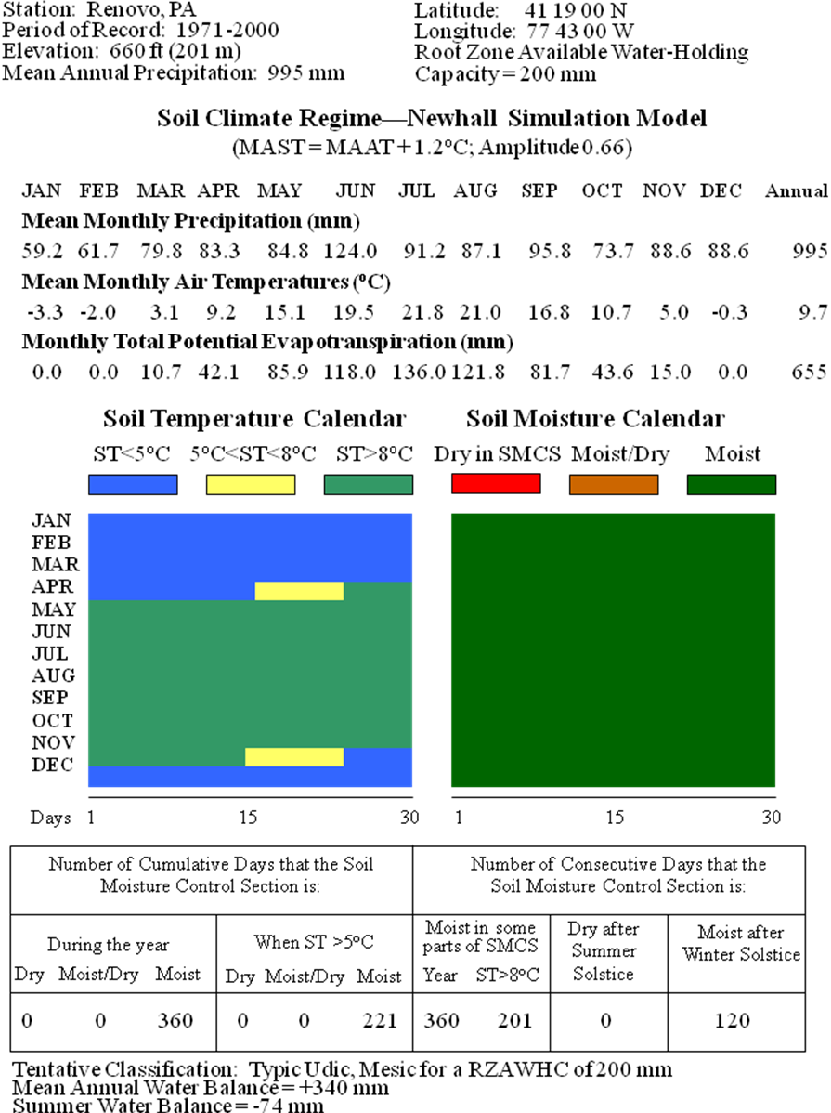

Appendix B: Output summary information, charts and data table. (cont’d)

The following information will be included in a report document and in a .csv file.

The Input Climate Data
Monthly mean annual air temperature values
Monthly mean annual precipitation values

Station/Site Metadata and Model Input Parameters
Station ID
Station Name
State
Country
Latitude
Longitude
Elevation
Hemisphere
Period of Record
Root zone available water holding capacity
Mean Annual Air Temperature (MAAT)
Mean Annual Soil Temperature (MAAT+1.0, or + 1.8, or + 2.5)

Newhall Simulation Model Results
Monthly PET (Potential Evapotranspiration)
Total PET (Potential Evapotranspiration)
Total Precipitation
MAAT (Mean Annual Air Temperature)
MAST (Mean Annual Soil Temperature)
AWB (Annual Water Balance)
SWB (Summer Water Balance)
BIO5 (cumulative days soil >5°C and moist)
BIO8 (consecutive days soil >8° C and moist in part)
NSM-STR (Normalized Soil Moisture – Soil Temperature Regime)
NSM-SMR (Normalized Soil Moisture – Soil Moisture Response)

Appendix B: Output summary information, charts and data table. (cont’d)

